SIMATS ENGINEERING
ASSESSMENT TOOL 1 Experiments

COURSE NAME: Computer Networks COURSE CODE: CSA07

COURSE OUTCOME COVERED

CO3: Analyze the performance of core network protocols such as TCP, UDP, HTTP, and
DNS under varying conditions
Assessment Tool Weightage: 40%
SOFTWARE: CISCO PACKET TRACER, WIRESHARK

EXPERIMENTS

QUESTIONS:4 Total Marks:40

- Design a simple LAN consisting of two PCs connected through a switch using Cisco Packet Tracer. Configure appropriate IP addresses for both hosts and verify connectivity using the ping command. Simultaneously capture the packet exchange using Wireshark. Identify the Ethernet frame fields such as Source MAC Address, Destination MAC Address, Ether type , and Frame Check Sequence (FCS). Explain how the Data Link layer uses MAC addressing to ensure successful frame delivery within the local network.

AIM:
To design and configure a simple LAN using Cisco Packet Tracer with two PCs connected through a switch, assign appropriate IP addresses, verify connectivity using the ping command, and analyze the captured Ethernet packets using Wireshark by identifying the Source MAC Address, Destination MAC Address, Ether Type, and Frame Check Sequence (FCS) fields.

PROCEDURE
- Open Cisco Packet Tracer and place two PCs and one switch in the workspace.
- Connect both PCs to the switch using Copper Straight-Through cables.
- Configure IP addresses: PC1 – 192.168.1.1 /24 and PC2 – 192.168.1.2 /24.
- Open the Command Prompt on PC1 and use ping 192.168.1.2 to verify connectivity.
- Capture the ping packet exchange using Wireshark on the connected network interface.
- Examine the captured Ethernet frame and identify the Source MAC, Destination MAC, Ether Type, and FCS fields.
- Analyze how MAC addressing at the Data Link layer enables the switch to forward frames to the correct PC within the LAN.

IMPLEMENTATION:
Screenshot 1:

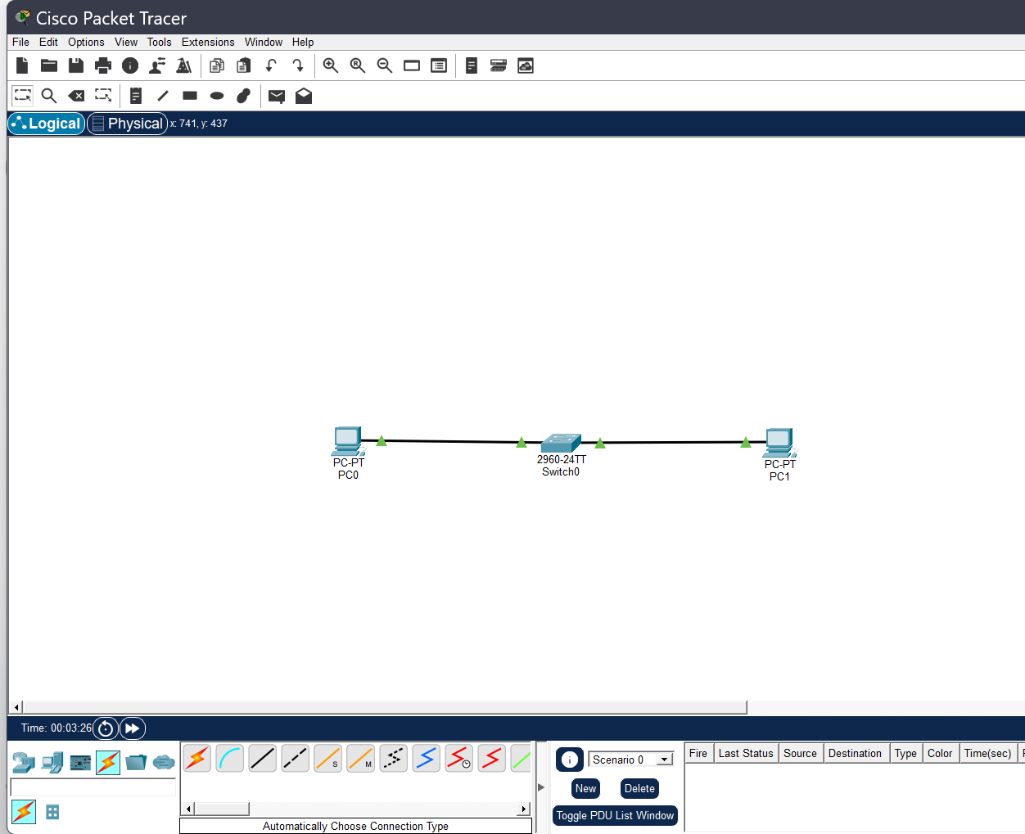
Fig.1 two pc’s connected through a switch

Explanation:
Two PCs are connected to a network switch using Ethernet cables. The switch enables the PCs to communicate with each other within the same LAN by forwarding data frames based on their MAC addresses.

Screenshot 2:
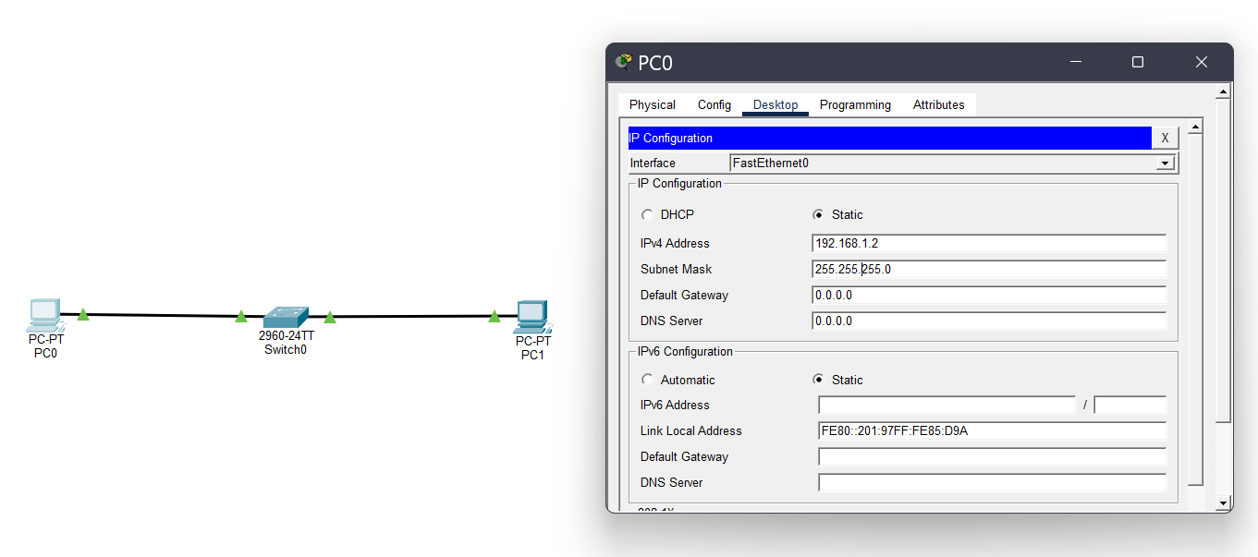
Fig2: IP configuration

Explanation:
IP addresses were assigned to both PCs in the same network. PC1 was configured with 192.168.1.1 and PC2 with 192.168.1.2, using the subnet mask 255.255.255.0. This allows both PCs to communicate within the same LAN.

Screenshot 3:
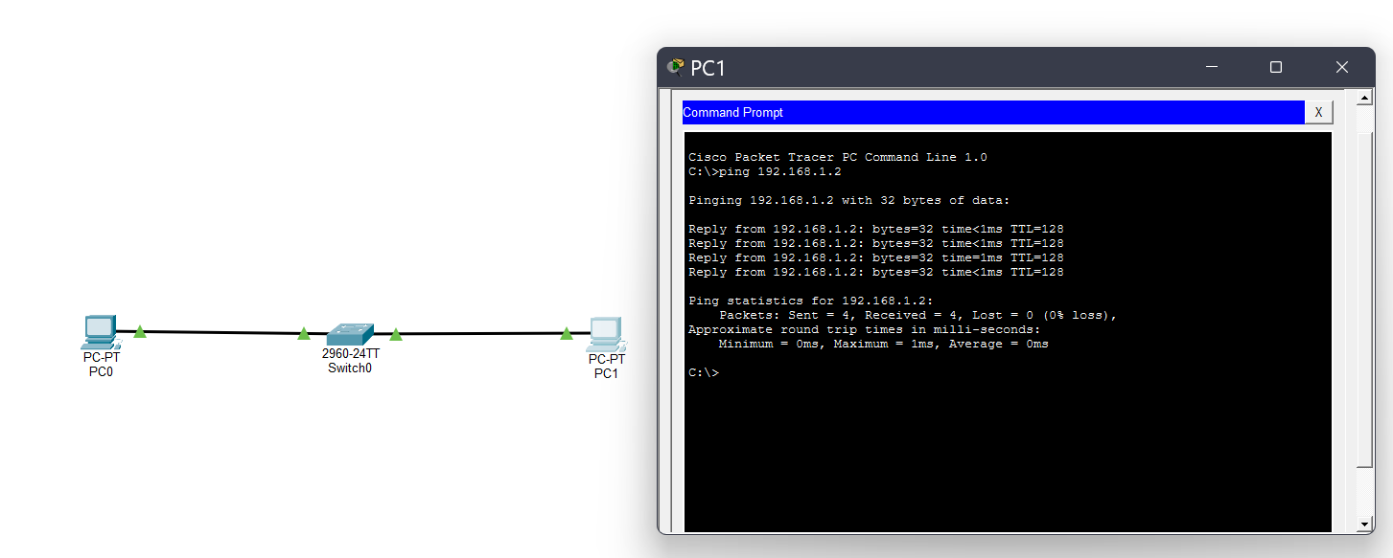
Fig 3: connectivity using ping command

Explanation:
The ping command was used to test connectivity between the two PCs.
PC1
(192.168.1.1) successfully received replies from PC2 (192.168.1.2),
confirming that the LAN connection was working correctly.

Screenshot 4:
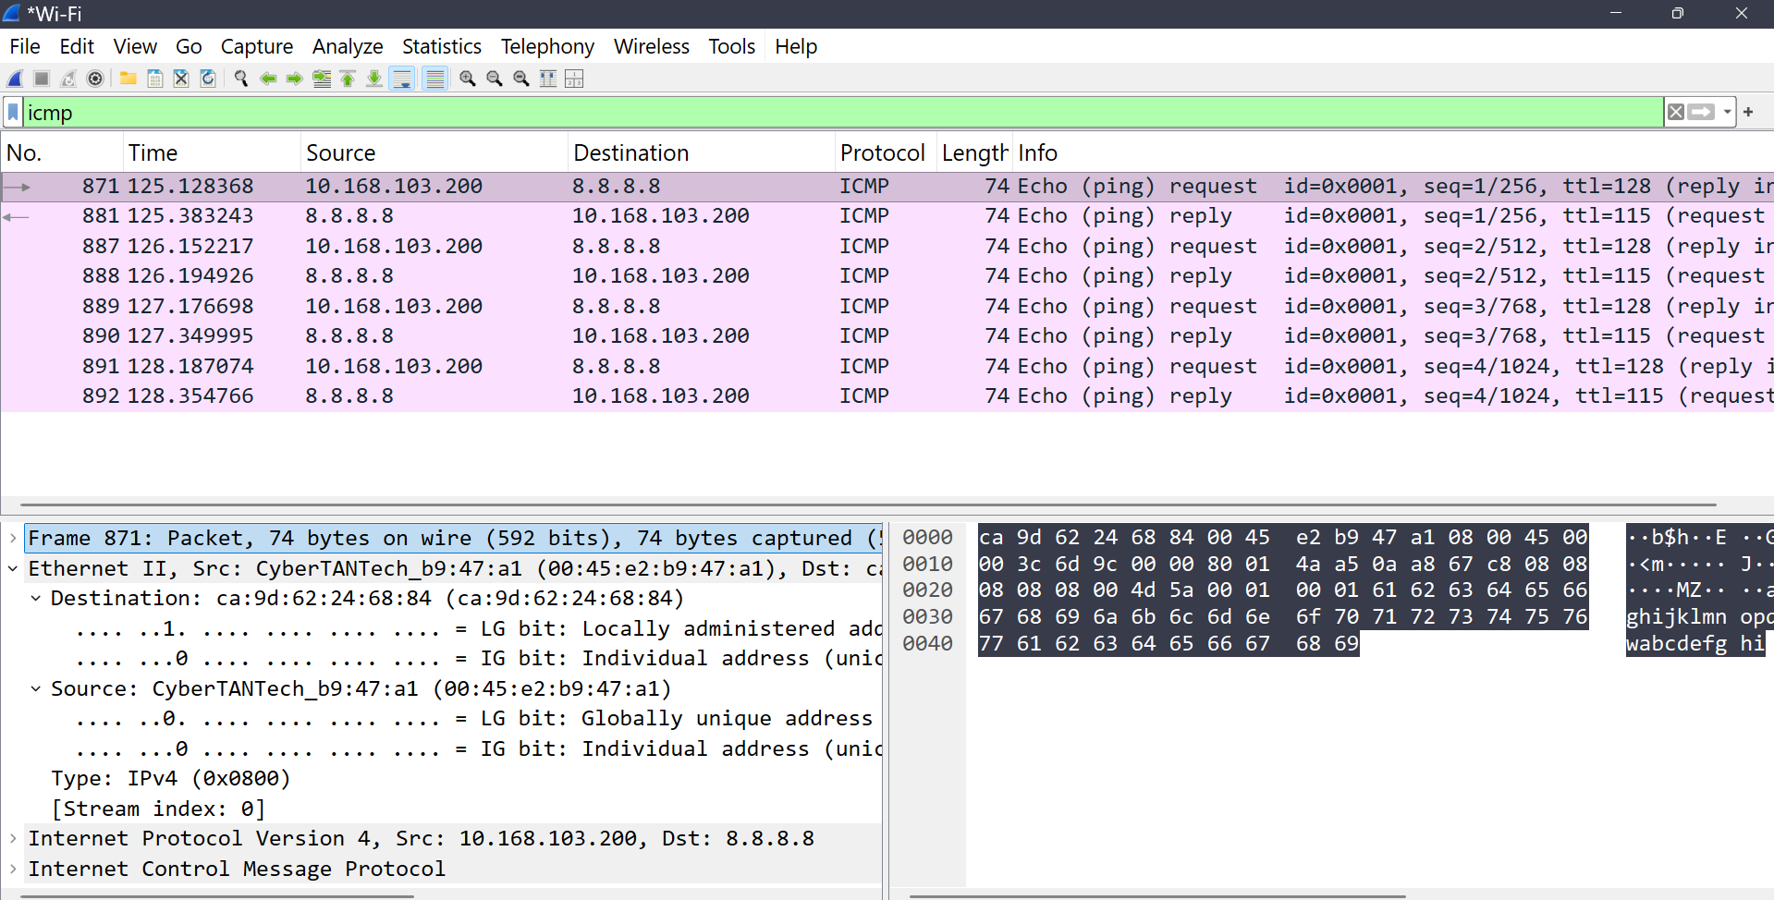
Fig :4 packet exchange using Wireshark

Explanation:
Wireshark was used to capture and analyze the ICMP Echo Request and
Echo Reply packets generated during the ping test. The captured packets
show the communication between the source and destination devices.

The Ethernet frame fields:

ETHERNET FIELD | VALUE
Destination MAC address | Ca:9d:62:24:68:84
Source MAC Address | 00:45:e2:b9:47:a1
Ether Type | 0x0800 — IPv4
Protocol | ICMP

Data Link Layer Explanation:

- The Data Link Layer is responsible for reliable communication between devices
- within the same local network.
- It uses MAC addresses to identify the source and destination devices. When
- frame is transmitted, the Source MAC Address identifies the sender, while
- Destination MAC Address identifies the intended receiver.
- The switch examines the destination MAC address and forwards the Ethernet frame
- through the appropriate port.
- The Ether type identifies the network-layer protocol carried in the frame, such as
- IPv4 (0x0800).
- The FCS is used for detecting errors in the Ethernet frame.

Result:
- A LAN consisting of two PCs connected through a switch was successfully
- designed and configured in Cisco Packet Tracer.
- IP addresses were assigned to both PCs, and connectivity was verified successfully
- using the ping command.
- The Ethernet frame was analyzed using Wireshark, and the Source MAC Address,
- Destination MAC Address, and Ether Type were identified.
- The experiment demonstrated how the Data Link Layer uses MAC addressing to
- ensure successful frame delivery within a local network.

2.Create a network topology consisting of two LANs connected through a router in Cisco Packet Tracer. Configure IPv4 addressing, subnet masks, and default gateways for all devices, and verify end-to-end communication using the ping command. Capture the ICMP packets using Wireshark and analyze the IPv4 header fields, including Source IP Address, Destination IP Address, Time-To Live (TTL), Protocol Number, and Header Length. Explain the role of the Network layer in forwarding packets between different networks.

Aim:
To design a network consisting of two LANs connected through a router, configure IPv4 addresses, subnet masks, and default gateways, verify end-to-end connectivity using the ping command, and analyze IPv4 header fields using Wireshark.

Procedure:
- Create a topology with 2 PCs, 2 switches, and 1 router, connecting each PC to a switch and both switches to the router.
- Connect the devices using Copper Straight-Through cables and configure the appropriate router interfaces.
- Assign IPv4 addresses and subnet masks to both PCs and configure their respective default gateways.
- Configure the router interfaces with 192.168.1.1/24 and 192.168.2.1/24 for the two LANs.
- Verify connectivity between the two LANs using the ping command from PC1 to PC2.
- Capture the ICMP packets using Wireshark and examine the IPv4 header fields such as Source IP, Destination IP, TTL, Protocol Number, and Header Length.
- Analyze how the Network Layer uses IP addressing and routing to forward packets between the two different LANs.

Implementation:

Screenshot:1 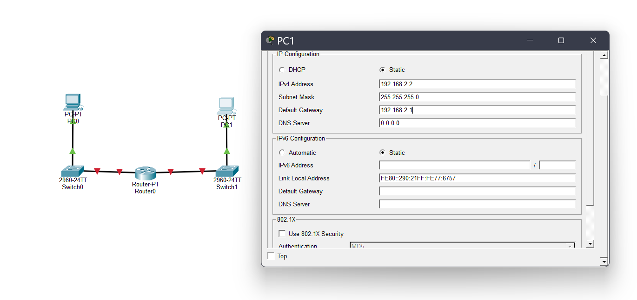
Fig 1: Ip configuration

Explanation:
IPv4 addresses, subnet masks, and default gateways were configured for both PCs.
PC0 was assigned 192.168.1.2 and PC1 was assigned 192.168.2.2, allowing
communication between the two different LANs through the router.

Screenshot 2:
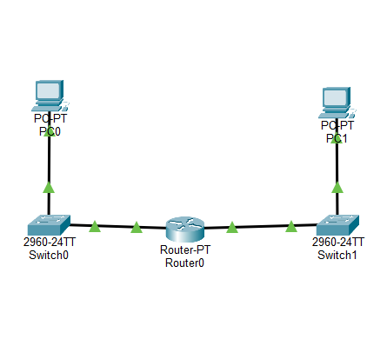
Fig 2: topology consisting of two LAN’s

Explanation:

Two separate LANs were created using two PCs and two switches, with a router
connecting the two networks. This allows devices in different LANs to
communicate with each other.

Screenshot 3:
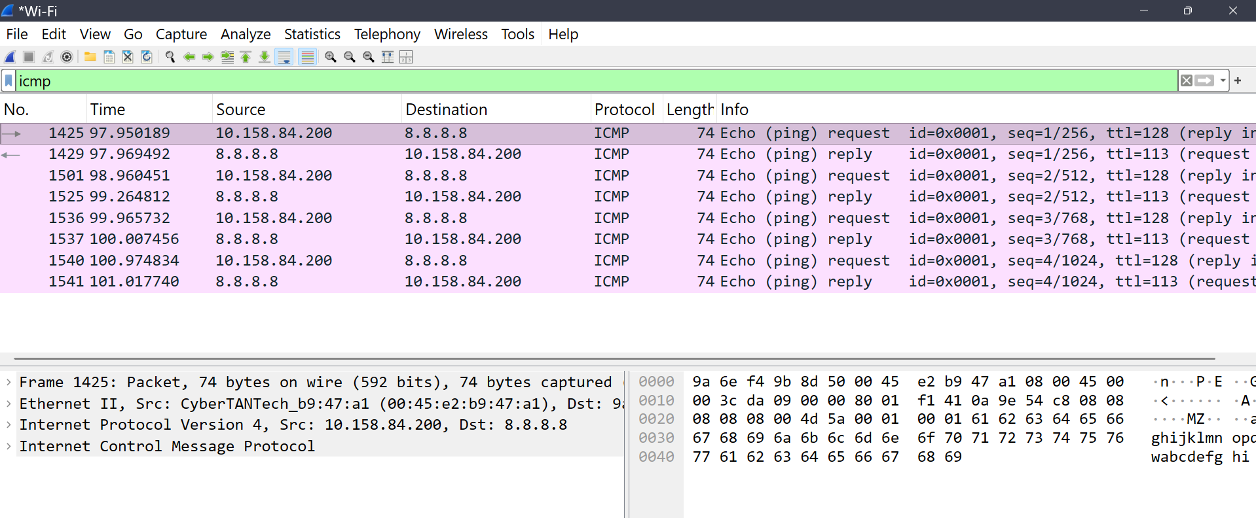
Fig:3 ICMP packets using wire shark

Explanation:
Wireshark was used to capture ICMP Echo Request and Echo Reply packets
generated during the ping test. The captured packets were analyzed to verify
communication between the source and destination devices.

IPv4 header fields:

Field | Value
Source IP Address | 10.158.84.200
Destination IP address | 8.8.8.8
Header length | 20 bytes
Time to live (TTL) | 128
Protocol Number | 1 (ICMP)

Explanation:
- Source IP Address: Identifies the device that sent the packet.
- Destination IP Address: Identifies the intended destination.
- Header Length: Indicates the size of the IPv4 header; here it is 20 bytes.
- TTL: Limits how long the packet can remain in the network. The value decreases by 1 at each router.
- Protocol Number: 1 indicates that the packet carries ICMP data.

Network Layer Explanation:

- The Network Layer is responsible for delivering packets between different networks.
- It uses IP addresses to identify the source and destination devices.
- The router connects the two LANs and forwards packets between them.
- The router checks the destination IP address to determine where to send the packet.
- Routing helps select the appropriate path for packet delivery.
- Thus, the Network Layer enables successful communication between devices on different LANs.
- It also helps control the TTL value, preventing packets from circulating endlessly in the network.

Result:
- The two separate LANs were successfully designed and interconnected using a router in Cisco Packet Tracer.
- IPv4 addresses, subnet masks, and default gateways were correctly configured for all devices.
- Communication between the two different networks was verified using the ping command, with successful replies and 0% packet loss.
- The ICMP packets were captured and analyzed using Wireshark, where the Source IP Address, Destination IP Address, Header Length, TTL, and Protocol Number of the IPv4 header were identified.
- The experiment demonstrated how the Network Layer and router work together to forward packets between different networks.

